**DAILY ONLINE ACTIVITIES SUMMARY**

|  |  |  |  |  |  |  |  |  |
| --- | --- | --- | --- | --- | --- | --- | --- | --- |
| **Date:** | 06-06-2020 | | | | | **Name:** | K S Prajwal | |
| **Sem & Sec** | Vi A sec | | | | | **USN:** | 4AL18CS032 | |
| **Online Test Summary** | | | | | | | | |
| **Subject** | | Data Communication | | | | | | |
| **Max. Marks** | | 30 | | **Score** | | | 27 | |
| **Certification Course Summary** | | | | | | | | |
| **Course** | **Python and Django Full Stack Web Developer Bootcamp** | | | | | | | |
| **Certificate Provider** | | | Udemy | | **Duration** | | | **3 hr** |
| **Coding Challenges** | | | | | | | | |
| **Problem Statement:**  1: Program to rotate an array by N positions | | | | | | | | |
| **Status:** completed | | | | | | | | |
| **Uploaded the report in Github** | | | | | yes | | | |
| **If yes Repository name** | | | | | <https://github.com/alvas-education-foundation/KS_Prajwal> | | | |
| **Uploaded the report in slack** | | | | | yes | | | |

Online Test Details: (Attach the snapshot and briefly write the report for the same)

Certification Course Details: (Attach the snapshot and briefly write the report for the same)

Coding Challenges Details: (Attach the snapshot and briefly write the report for the same)

**Online Test Details:** It was about the topic from module 5. The questions were all multiple-choice questions which were optimal and easy to solve. The score that I got was 27/30.

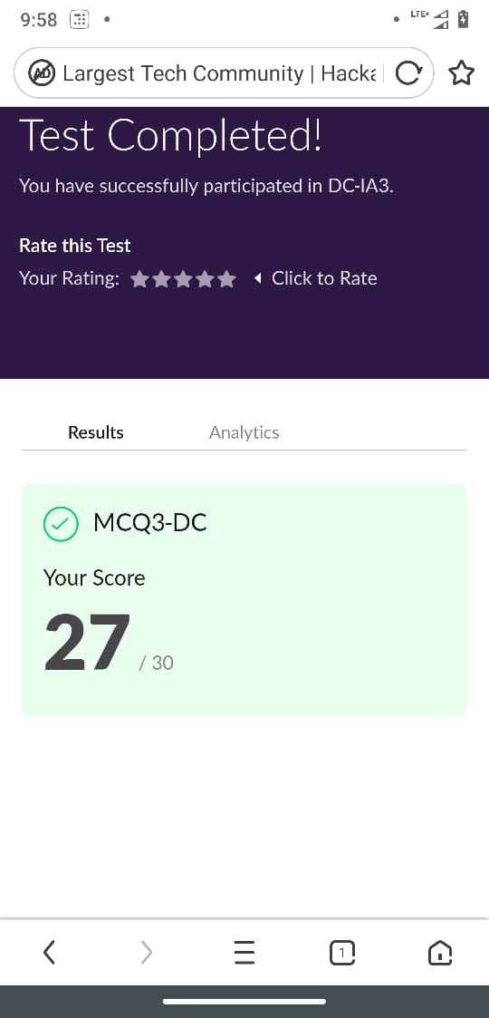

Snapshot of certification course:

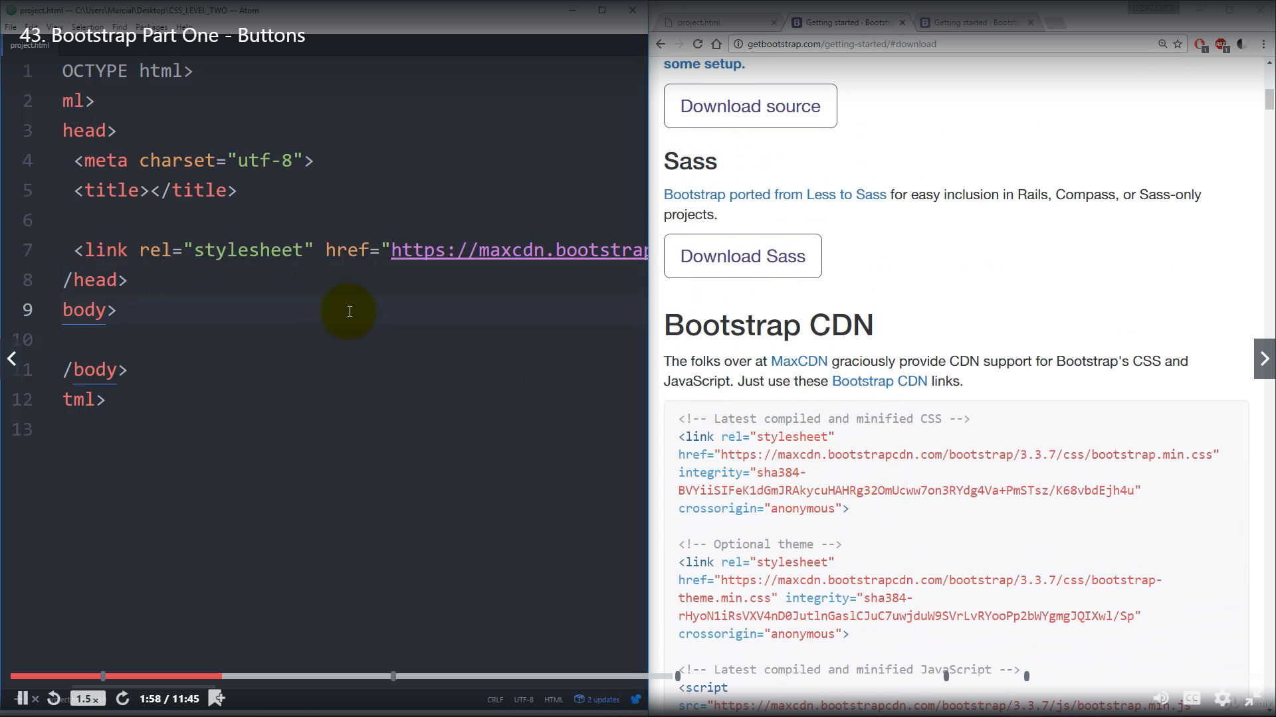

It was about the basics of bootstrap how to implement it in our web page and modifying it.

**Online coding:**

Problem 1: (using C) program to rotate an array by N positions